**STAFF PROFILE**

**Dr. POONAM SHUKLA**

Asso. Prof. & Head

Mob. +9453377431

e-Mail : poonamshukla.1980@gmail.com

……………………..More

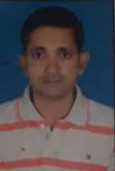

**BRIJESH KUMAR PANDEY**

Asso. Prof.

Mob. +8004643456

e-Mail : brijeshpandey@gmail.com

……………………..More

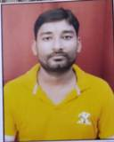

**RAGVINDRA PRATAP SINGH**

Asso. Prof.

Mob. +8115191927

e-Mail : ragvindrapratap.1978@gmail.com

……………………..More

**SANJAY KUMAR PANDEY**

Asso. Prof.

Mob. +9451027576

e-Mail : sanjay@gmail.com

……………………..More



**SEEMA SINGHAL SHARMA**

Asso. Prof.

Mob. +8659134313

e-Mail : seemasinghal.1975@gmail.com

……………………..More